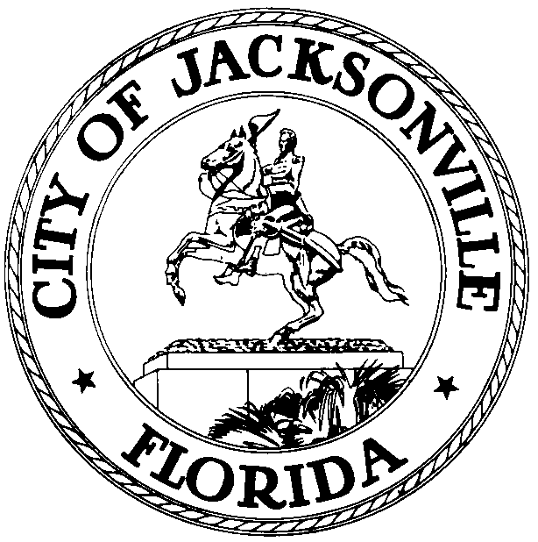

OFFICE OF THE CITY COUNCIL

CHERYL L. BROWN 117 WEST DUVAL STREET, SUITE 425
DIRECTOR 4TH FLOOR, CITY HALL
OFFICE (904) 630-1452 JACKSONVILLE, FLORIDA 32202
FAX (904) 630-2906
E-MAIL: CLBROWN@coj.net

Special CIP Committee Meeting Minutes
September 24, 2014
1:00 p.m.

Location: Lynwood Roberts Room, 1st floor, City Hall – St. James Building; 117 West Duval Street,
Suite 425

In attendance: Council Members Lori Boyer (Chair), Bill Gulliford, Matt Schellenberg and Greg Anderson

Also: Council Members John Crescimbeni, Jim Love, Don Redman and Warren Jones; Kirk Sherman, Janice Billy, Phillip Peterson – Council Auditor’s Office; Paula Shoup – Legislative Services Division; Peggy Sidman – Office of General Counsel; Jeff Clements – Council Research Division; Ronnie Belton, Glenn Hansen, Joey Greive, Marc Stickney – Finance Department; John Pappas – Public Works Department; George McGregor – HDR Engineering

Meeting Convened: 1:05 p.m.

Council Member Boyer convened the meeting and announced that the committee would not meet next week in recognition of the City Council’s “5th week”. She reported that she had met last week with the JTA and has another meeting scheduled with them for next week, after which the committee should be able to wrap up work on the road portion of the Better Jacksonville Plan project list. More work needs to be done on outstanding condemnations and their attendant unknown costs, and she asked George McGregor to communicate with Deputy General Counsel Peggy Sidman on potential attorney costs.

Stormwater utility
Deputy Director of Public Works John Pappas distributed a revised project list containing the information requested by the committee at its meeting last week with more columns reporting project authorizations and deauthorizations, encumbrances, cash balances, borrowing and anticipated additional financial needs to complete the projects. The committee requested an additional column on the spreadsheet showing how much money was borrowed for each project versus allocated from pay-as-you-go resources. Marc Stickney explained how funds are authorized for projects and how spending begins before authorized funds are borrowed using transferred funds from other projects, to be paid back at a later time by subsequent borrowing. Council Member Boyer expressed concern about the “disconnect” that occurs in the Banking Fund between authorizations and actual distribution of cash among projects and the difficulty that causes council members in being able to track the funding status of individual projects within the Finance Department’s use of pooled authorizations to shift cash among projects.. Mr. Stickney explained the IRS regulations on the timing of the use of borrowed funds and the City’s preference to borrow funds in arrears and pay back projects for expenditures already made from other available funds. Assistant Council Auditor Janice Billy expressed agreement with the Finance Department’s borrowing and cash allocation mechanism as an appropriate method to most accurately match cash generation with cash needs and minimize borrowing before projects are ready for expenditures.

Chairwoman Boyer said that the cash management and borrowing system currently being used that relies on shifting cash among projects and paying project costs in arrears makes it very difficult for the Council to predict debt service needs in future fiscal years and removes the incentive to actively pursue some CIP projects when other priorities arise and take precedence, leaving some projects authorized but undone for many years.

The stormwater utility fee currently generates approximately $30 million per year; operating expenses (personnel, contractual services, etc.) are approximately $18 million per year; debt service on pre-existing borrowing and Banking Fund borrowing is approximately $5.6 million; the cost of TMDL environmental credit purchase is $2.5 million for 8 years; debt service on new borrowing authorized in the budget last night is $1.8 million; leaving approximately $2 million for pay-as-you-go capital and other purposes. John Pappas explained how the stormwater fee is assessed to property owners based on the amount of impervious surface on a lot; Council Member Gulliford requested information on how Jacksonville’s stormwater fee compares with other jurisdictions in Florida. Mr. Pappas said the City is working with JEA on spending the $6 million in available cash for septic tank phase-out projects. Council Member Jones cited an inequity in the City paying for homeowner connections to public sewer in cases where properties are located near a water body and for which the City can get credit for cleaning up surface water, but not paying for hook-ups for owners of failing septic tanks that aren’t near a water body. Ms. Boyer suggested that it may be time to look at resurrecting the Water and Sewer Expansion Authority to deal with that problem, and also noted that the Zoning Code prohibits the use of septic tanks where they would be problematic near water bodies, but the City’s development review process takes no cognizance of septic tank issues in permitting developments. Teresa Eichner said that she has been working with JEA on identifying neighborhoods that are not served by public water and/or sewer so that the City can begin developing a strategy for a comprehensive septic tan phase-out initiative.

Better Jacksonville Plan
Chairwoman Boyer requested for the next meeting a separate listing of projects that are completed and don’t have any outstanding encumbrances, condemnations, etc. that are ready for complete close-out and removal from the list. She also requested more detailed information on projects needing tree mitigation – the updated cost of planting the required trees versus the cost of paying into the mitigation fund in lieu of planting. She wants the committee to be thinking about ways to pay for the obligations for which there is no current funding available.

Daryl Joseph, Acting Director of Parks, Recreation and Community Services, cited several recreation projects on the BJP list that have negative cash balances and don’t have a ready source of funding for completion of those projects. Kristi Holochek and Tony Allegretti representing the Art in Public Places Commission said that the commission is ready to begin procuring the art for the county courthouse project if the money is actually available. The fund currently shows no cash balance so the funding will need to be borrowed or obtained from some other source. Mr. Allegretti noted that the installation of public art is mandated in the Ordinance Code so funding needs to be found somewhere. Chairwoman Boyer likened the public art obligation to the unfinished condemnations on road projects and the unplanted trees required by the tree mitigation regulations; they are obligations to the project that need to be fulfilled before the projects can be considered complete. Laura Stagner of the Housing and Community Development Division cited 2 Northwest Quadrant Economic Development Fund projects that have remaining financial obligations to be paid. John Pappas asked the departmental representatives to provide additional detail on the status of their projects for inclusion on the next iteration of the project spreadsheet.

Meeting Adjourned: 2:54 p.m.

Minutes: Jeff Clements, Council Research Division
9.24.14 Posted 3:00 p.m.
Tapes: Special CIP Committee – LSD
9.24.14
Materials: Special CIP Committee handouts
9.24.14

